|  |  |
| --- | --- |
| Ex.No: 1 | **Study of Network Tool – Packet Tracer** |
| Date : |

# Objectives:

To introduce, explore and get familiar with using Cisco Packet Tracer simulator program to implement the different lab exercises of the networking course.

# Introduction:

Packet Tracer [https:/www.netacad.com/courses/packet-tracer](https://www.netacad.com/courses/packet-tracer) is a network design, simulation and modelling tool that allows you to develop your skill set in networking, cybersecurity, and the Internet of Things (IoT). It allows you to model complex systems without the need for dedicated equipment. Using [Packet Tracer,](https://www.sysnettechsolutions.com/en/what-is-cisco-packet-tracer-software/) you can create detailed projects by creating Network topologies or create a virtual environment of your existing network with this software

# Requirements:

1. You must enroll in and go through the free course Introduction to Packet Tracer provided by Cisco Networking Academy (Netacad) through the following link: <https://www.netacad.com/portal/web/self-enroll/m/course-262199>

This is a free course to help you understand and work with Packet Tracer. It is short and helpful one, so please make sure you get benefit from it.

1. You must download and install Cisco Packet Tracer version 7.3.1 (8.2.1 is the recent version) on your computer.
2. To start the Packet Tracer simulator, you will be asked to log in to your Cisco account (which you have created earlier) for verification. (else you may use guest login)

# In this Lab:

1. You will download and install Packet Tracer version 8.2.1
2. 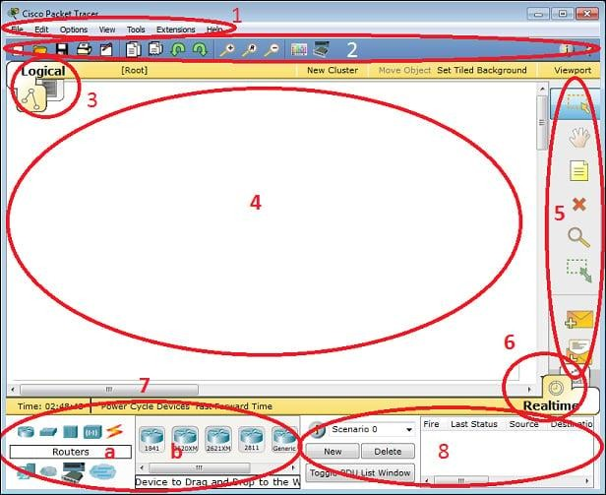You will explore the Packet Tracer User Interface and functions. 3-You will create a simple network topology Interface overview

The components of the Packet Tracer interface are as follows:

**Area 1: Menu bar** – This is a common menu found in all software applications; it is used to open, save, print, change preferences, and so on.

**Area 2: Main toolbar** – This bar provides shortcut icons to menu options that are commonly accessed, such as open, save, zoom, undo, and redo, and on the right-hand side is an icon for entering network information for the current network.

**Area 3: Logical/Physical workspace tabs** – These tabs allow you to toggle between the **Logical** and **Physical** work areas.

**Area 4: Workspace** – This is the area where topologies are created and simulations are displayed.

**Area 5: Common tools bar** – This toolbar provides controls for manipulating topologies, such as select, move layout, place note, delete, inspect, resize shape, and add simple/complex PDU.

**Area 6: Realtime/Simulation tabs** – These tabs are used to toggle between the real and simulation modes. Buttons are also provided to control the time, and to capture the packets.

**Area 7: Network component box** – This component contains all of the network and end devices available with Packet Tracer, and is further divided into two areas:

**Area 7a: Device-type selection box** – This area contains device categories

**Area 7b: Device-specific selection box** – When a device category is selected, this selection box displays the different device models within that category

**Area 8: User-created packet box** – Users can create highly-customized packets to test their topology from this area, and the results are displayed as a list.

Make sure you are familiar with these names, because moving forward we will be referring to them frequently.

# Creating a simple topology

* 1. Open the *cisco packet tracer* application
  2. Simple Network Installation Preparation in this example is to use 2 workstations (PCs) and 1 switch. Each node is connected to the cable.
  3. Select the icon of the PC that sits in the left corner and then put on display

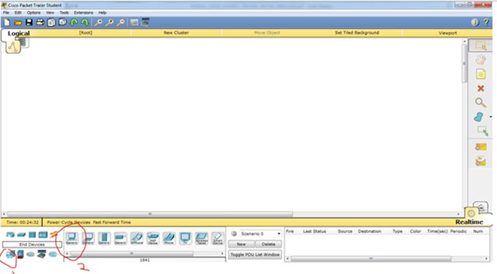

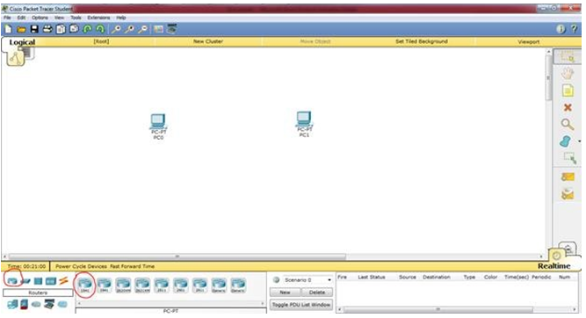

* 1. 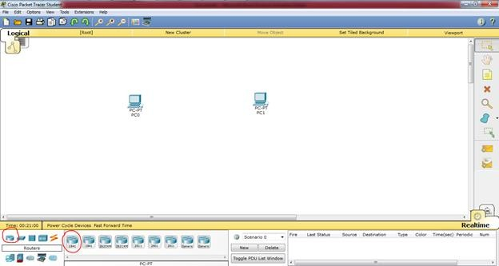Place the 2 pieces on the PC display
  2. 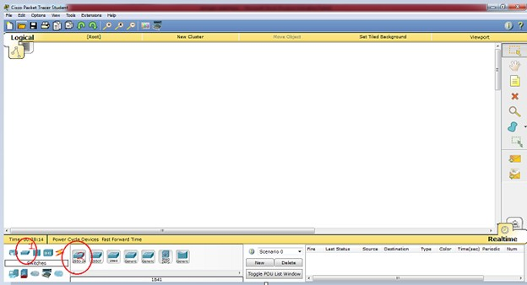Next select switch and put on display
  3. The process of wiring to connect 2 PC, select the straight cable, create an image such as this, when the wires yet is green then the PC yet connect

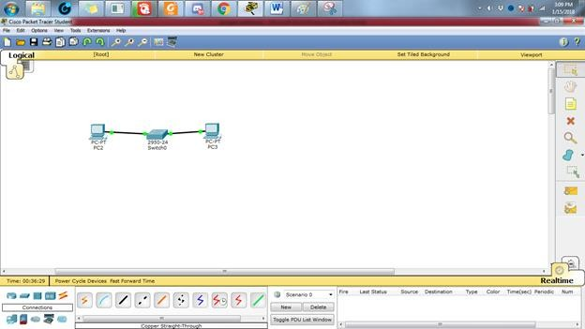

* 1. And then do the configuration IP address host **PC0** by means of double-click image **PC0**, then click the tab of the Desktop and choose menu section the IP Configuration so that the display is visible on the picture below This

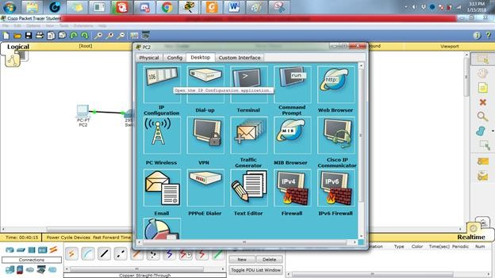

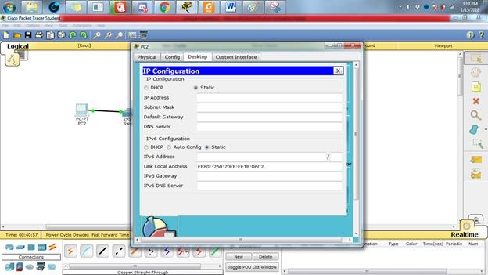

* 1. Add the IP Address **192.168.123.1** and Subnetmask will come out automatically
  2. Do the same on the workstation configuration is as follows: each PC with a different ip address

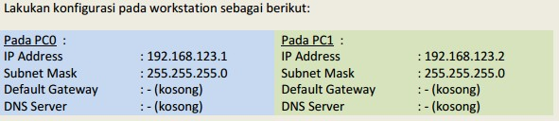

# PING

* 1. To test the connection between the two nodes using the "ping" utility. To start the ping from **PC0 PC1** headed, double-click the **PC0** making it appear properties window for **PC0**, then select the tab of the **Desktop**, then select the **menu Command Prompt** so that it appears look like Figure below.

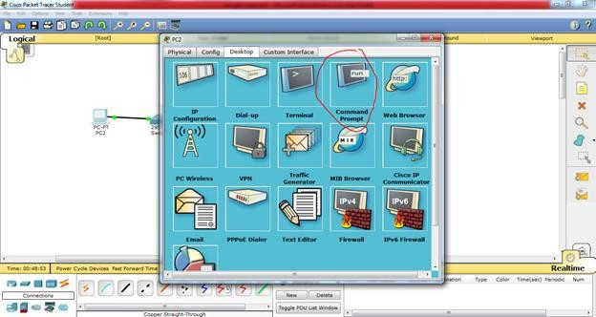

* 1. **.**Do a "ping" by way of typing: ping [ip_address_target] to do ping towards **PC1** which has IP address 192.168.123.2 is by way of type in: **ping 192.168.123.2 .** If the configuration you do is correct then the produced output like this:

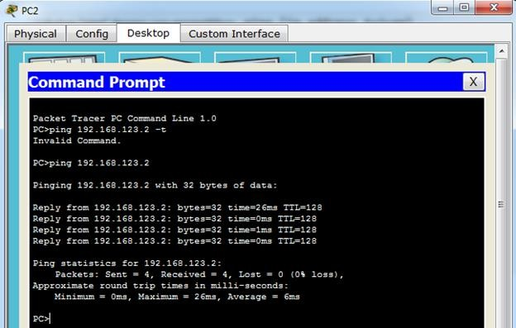

# CONCLUSION

From the results of experiments conducted, it can be concluded that:

1. The new **PC0** and **PC1** workstations can be connected if both workstation IP addresses have been well configured and correct.
2. To test connectivity between nodes can use the "ping" command

# Rubrics for Experiment Assessment:

|  |  |  |  |  |
| --- | --- | --- | --- | --- |
| **Rubrics** | **Good** | **Normal** | **Poor** | **Marks** |
| **Creation of Topology (4)** | Created the topology, Identify the proper devices and making the  connections **(4)** | Created the topology, Identify the proper devices, making the connections But missing some features  **(3)** | Created wrong topology, Failed to Identify the proper devices and making  connections **(1)** |  |
| **Verify the**  **connectivity (4)** | Verified the  connectivity in all the levels **(4)** | Verified the connectivity at  some levels (only some nodes) **(2)** | Verified the  connectivity is not done. **(1)** |  |
| **Timely Completion**  **(2)** | Completed the lab before the allotted  time **(2)** | Completed the lab after the deadline **(1)** | Did not submitted before grading **(0)** |  |
| **Tota**l | | | |  |